Quality Assurance Report
2018 EOG SGPs

This document serves as the quality assurance report for 2018 EOG SGPs. The following descriptive statistics were used as part of the quality assurance process in evaluating the calculations for the 2018 SGPs: the percentage of students who received SGPs, the correlation between median SGPs and mean prior scores, and the correlation between SGPs and Growth Targets.
Summary of findings:
1. | More than 93% of students received SGPs in 2018. The percentage of students who received an SGP in each grade and subject are consistent with previous years (see Table 1). Most of the districts/schools with low SGP percentages are from the DJJ or various treatment centers. Tables 1.1 and 1.2 in Appendix A contain a list of districts and schools with the lowest SGP percentages.
2. | The Mean SGPs for ELA and Math are approximately 50, with negligible differences that are accounted for by typical model fit. Those numbers are consistent with previous years (see Table 2).
3. | The correlation between Mean SGP and average prior achievement are slightly lower than previous years (see Table 3).
4. | There are small-to-moderate negative correlations between SGPs and growth targets (-0.31 ≤ r_{xy} ≤ -0.17). These correlation values are expected as higher SGPs in the current year would require less growth in the next year (see Table 4). Figures 1-3 also support this finding.

Table 1: Percent of Students who Received SGPs by Subject and Grade

Subject | Grade | N SGP | N SCORE | % SGP | N SGP | N SCORE | % SGP | N SGP | N SCORE | % SGP
 |  | 2016 | 2016 | 2016 | 2017 | 2017 | 2017 | 2018 | 2018 | 2018
ELA | 4 | 123,767 | 132,230 | 93.60% | 127,510 | 135,632 | 94.01% | 127,588 | 136,218 | 93.66%
ELA | 5 | 122,053 | 129,653 | 94.14% | 125,539 | 132,854 | 94.49% | 128,687 | 137,142 | 93.83%
ELA | 6 | 119,853 | 128,244 | 93.46% | 121,760 | 129,406 | 94.09% | 124,371 | 132,991 | 93.52%
ELA | 7 | 118,962 | 127,512 | 93.29% | 121,056 | 128,941 | 93.88% | 121,958 | 130,349 | 93.56%
ELA | 8 | 120,474 | 128,550 | 93.72% | 120,100 | 127,502 | 94.19% | 117,070 | 124,961 | 93.69%
MATHEMATICS | 4 | 124,313 | 132,736 | 93.65% | 127,870 | 136,223 | 93.87% | 127,989 | 136,124 | 94.02%
MATHEMATICS | 5 | 122,680 | 130,182 | 94.24% | 125,925 | 133,480 | 94.34% | 129,130 | 137,092 | 94.19%
MATHEMATICS | 6 | 120,376 | 128,571 | 93.63% | 122,108 | 129,803 | 94.07% | 124,765 | 132,861 | 93.91%
MATHEMATICS | 7 | 118,986 | 127,439 | 93.37% | 120,879 | 128,996 | 93.71% | 121,786 | 129,773 | 93.85%
MATHEMATICS | 8 | 102,088 | 109,759 | 93.01% | 98,493 | 105,416 | 93.43% | 97,805 | 104,619 | 93.49%

Table 2: Mean SGPs across Years – State Level
Subject | SIMEX MeanGP  2015 | SIMEX MeanGP  2016 | Ranked SIMEX  MeanGP  2017 | Ranked SIMEX  MeanGP  2018
ELA | 49.94 | 49.80 | 50.06 | 50.08
MATHEMATICS | 50.09 | 50.02 | 50.05 | 50.05

Table 3: Correlations between Mean SGPs and Mean Standardized Prior Scores (N≥15) – School Level
 | School Level  Correlation  (2015) |  | School Level  Correlation  (2016) |  | School Level  Correlation  (2017) |  | School Level  Correlation  (2018)
Subject | Uncorrected MeanGP | SIMEX MeanGP | Uncorrected MeanGP | SIMEX MeanGP | Uncorrected MeanGP | Ranked  SIMEX MeanGP | Uncorrected MeanGP | Ranked  SIMEX MeanGP
ELA | 0.42 | 0.26 | 0.59 | 0.43 | 0.52 | 0.33 | 0.48 | 0.29
Mathematics | 0.46 | 0.36 | 0.51 | 0.41 | 0.42 | 0.30 | 0.40 | 0.29

Table 4: Correlations between SGPs and Growth Targets

Subject | Grade | SGP vs.  Developing Target | SGP vs.  Proficient Target | SGP vs.  Distinguished Target
ELA | 4 | -0.30 | -0.29 | -0.23
ELA | 5 | -0.24 | -0.24 | -0.22
ELA | 6 | -0.25 | -0.25 | -0.23
ELA | 7 | -0.23 | -0.24 | -0.23
ELA | 8 | -0.24 | -0.24 | -0.20
MATHEMATICS | 4 | -0.30 | -0.31 | -0.26
MATHEMATICS | 5 | -0.25 | -0.23 | -0.20
MATHEMATICS | 6 | -0.30 | -0.27 | -0.22
MATHEMATICS | 7 | -0.22 | -0.24 | -0.22
MATHEMATICS | 8 | -0.31 | -0.26 | -0.17

Figures 1-3 show examples of the relationship between SGPs and Growth Targets (which did not tend to differ across subject areas and grade levels). Students who demonstrated very high SGPs had an increased likelihood of receiving targets that were lower, which led to the negative correlations observed above in Table 4. In other words, Pearson correlation values are used to describe linear relationships, but the non-linearity of the data require Figures 1-3 to better understand the assocation between SGPs and Growth Targets. As would be expected across figures, the distinguished targets in Figure 3 were harder to attain than the developing targets in Figure 1. Both sets of findings were expected.
Figure 1: The scatter plot of SGPs and Developing Targets in Grade 4
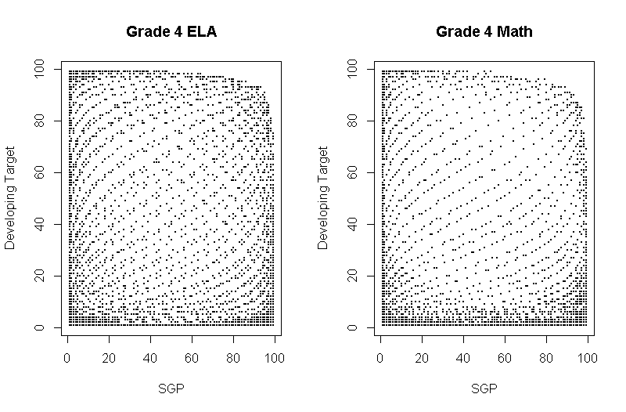
Figure 2: The scatter plot of SGPs and Proficient Targets in Grade 4 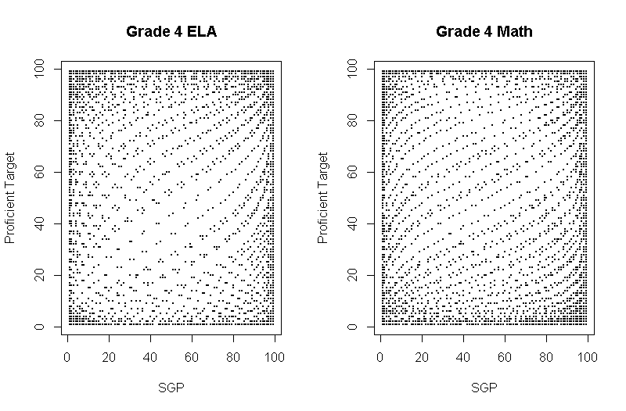
Figure 3: The scatter plot of SGPs and Distinguished Targets in Grade 4 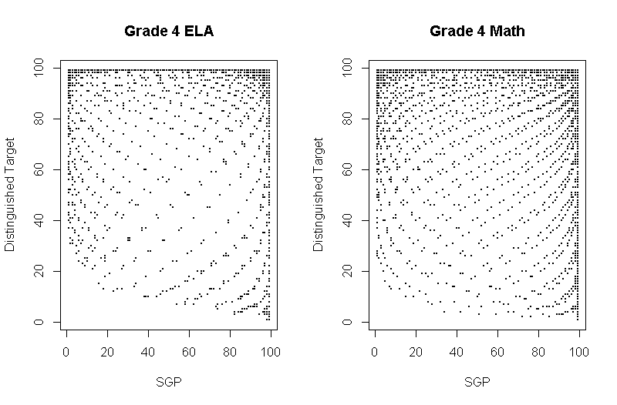

Appendix A
Table 1.1: Districts with lowest % received SGP
Subject | System  ID | System  Name | N  SGP | N  TOTAL | % Received  SGP | Note
Math | 891 | Department of Juvenile Justice | 13 | 39 | 33.33% | 64.1% grade repeaters and 2.56% new to the state students
ELA | 891 | Department of Juvenile Justice | 14 | 39 | 35.90% | 61.54% grade repeaters and 2.56% new to the state students
ELA | 7830612 | State Charter Schools II- Southwest Georgia S.T.E.M. Charter Academy | 68 | 96 | 70.83% | 17.71% grade repeaters and 11.46% new to the state students
Math | 7830612 | State Charter Schools II- Southwest Georgia S.T.E.M. Charter Academy | 68 | 96 | 70.83% | 17.71% grade repeaters and11.46% new to the state students
ELA | 7820412 | State Charter Schools- Georgia Connections Academy | 1,148 | 1,455 | 78.90% | 15.19% grade repeaters and9.28% new to the state students
Math | 7820412 | State Charter Schools- Georgia Connections Academy | 1,134 | 1,437 | 78.91% | 15.45% grade repeaters and10.3% new to the state students
ELA | 7991893 | State Schools- Atlanta Area School for the Deaf | 37 | 45 | 82.22% | 15.56% grade repeaters and 2.22% new to the state students
ELA | 7830615 | State Charter Schools II- Genesis Innovation Academy for Boys | 75 | 91 | 82.42% | 17.58% grade repeaters and 0% new to the state students
Math | 7830615 | State Charter Schools II- Genesis Innovation Academy for Boys | 75 | 91 | 82.42% | 17.56% grade repeaters and 0% new to the state students
ELA | 7830616 | State Charter Schools II- Genesis Innovation Academy for Girls | 61 | 74 | 82.43% | 17.56% grade repeaters and 0% new to the state students
Math | 7830616 | State Charter Schools II- Genesis Innovation Academy for Girls | 61 | 74 | 82.43% | 17.58% grade repeaters and 0% new to the state students
ELA | 689 | Liberty County | 3,081 | 3,693 | 83.43% | 15.62% grade repeaters and 1.03% new to the state students
Math | 689 | Liberty County | 3,085 | 3,686 | 83.70% | 15.44% grade repeaters and 1.14% new to the state students
ELA | 626 | Chattahoochee County | 195 | 229 | 85.15% | 13.54% grade repeaters and 1.31% new to the state students
Math | 626 | Chattahoochee County | 191 | 224 | 85.27% | 13.84% grade repeaters and 3.13% new to the state students
Math | 7991893 | State Schools- Atlanta Area School for the Deaf | 38 | 44 | 86.36% | 13.64% grade repeaters and 2.27% new to the state students
Math | 7820120 | State Charter Schools- Georgia Cyber Academy | 3,920 | 4,536 | 86.42% | 11.97% grade repeaters and 3.33% new to the state students
ELA | 7820120 | State Charter Schools- Georgia Cyber Academy | 3,928 | 4,537 | 86.58% | 12.26% grade repeaters and 3.22% new to the state students
ELA | 7820614 | State Charter Schools- International Charter School of Atlanta | 146 | 167 | 87.43% | 11.98% grade repeaters and 0.6% new to the state students

Table 1.2: Schools with lowest % received SGP
SUBJECT | System  ID | SYSTEM  NAME | SCHOOL  NUMBER | SCHOOL  NAME | N  SGP | N  Total | % Received  SGP
ELA | 667 | Gwinnett County | 6671817 | International Transition Center | 1 | 24 | 4.17%
MATHEMATICS | 667 | Gwinnett County | 6671817 | International Transition Center | 2 | 24 | 8.33%
ELA | 891 | Department of Juvenile Justice | 8910298 | Augusta Youth Development Campus | 2 | 5 | 40.00%
MATHEMATICS | 891 | Department of Juvenile Justice | 8910298 | Augusta Youth Development Campus | 2 | 5 | 40.00%
MATHEMATICS | 891 | Department of Juvenile Justice | 8910405 | Muscogee Youth Development Center | 6 | 15 | 40.00%
ELA | 891 | Department of Juvenile Justice | 8910405 | Muscogee Youth Development Center | 7 | 15 | 46.67%
MATHEMATICS | 644 | DeKalb County | 6441100 | International Student Center | 118 | 235 | 50.21%
ELA | 644 | DeKalb County | 6441100 | International Student Center | 123 | 238 | 51.68%
MATHEMATICS | 633 | Cobb County | 6330807 | Devereux Ackerman Academy | 19 | 34 | 55.88%
ELA | 733 | Taylor County | 7330107 | Georgia Center | 9 | 16 | 56.25%
MATHEMATICS | 733 | Taylor County | 7330107 | Georgia Center | 9 | 16 | 56.25%
ELA | 633 | Cobb County | 6330807 | Devereux Ackerman Academy | 20 | 34 | 58.82%
MATHEMATICS | 645 | Dodge County | 6450292 | DAC (Dodge County Achievement Center) | 9 | 15 | 60.00%
MATHEMATICS | 721 | Richmond County | 7210103 | Freedom Park Elementary | 189 | 306 | 61.76%
ELA | 645 | Dodge County | 6450292 | DAC (Dodge County Achievement Center) | 10 | 16 | 62.50%
ELA | 721 | Richmond County | 7210103 | Freedom Park Elementary | 201 | 318 | 63.21%
ELA | 736 | Thomas County | 7360100 | Bishop Hall Charter School | 11 | 17 | 64.71%
MATHEMATICS | 736 | Thomas County | 7360100 | Bishop Hall Charter School | 11 | 17 | 64.71%
ELA | 622 | Carroll County | 6220112 | KidsPeace | 12 | 18 | 66.67%

